QUESTION:1
we define a local procedure within an anonymous plsql block to calculate and display the sum of two number
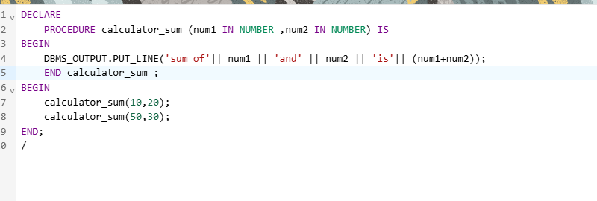
DECLARE
PROCEDURE calculator_sum (num1 IN NUMBER ,num2 IN NUMBER) IS
BEGIN
DBMS_OUTPUT.PUT_LINE('sum of'|| num1 || 'and' || num2 || 'is'|| (num1+num2));
END calculator_sum ;
BEGIN
calculator_sum(10,20);
calculator_sum(50,30);
END;
/

this example demostrate howto create a stored procedure that accept to number
calculate their sum and return the result
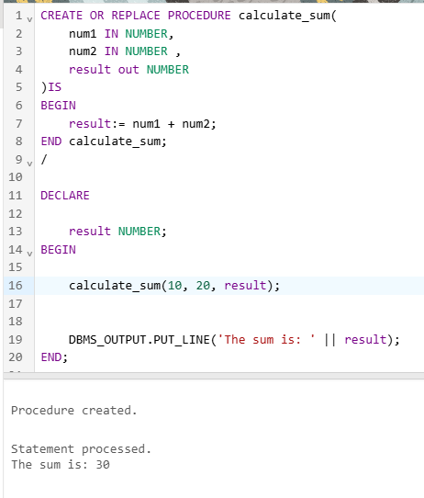

CREATE OR REPLACE PROCEDURE calculate_sum(
num1 IN NUMBER,
num2 IN NUMBER ,
result out NUMBER
)IS
BEGIN
result:= num1 + num2;
END calculate_sum;
/

DECLARE

result NUMBER;
BEGIN

calculate_sum(10, 20, result);

DBMS_OUTPUT.PUT_LINE('The sum is: ' || result);
END;

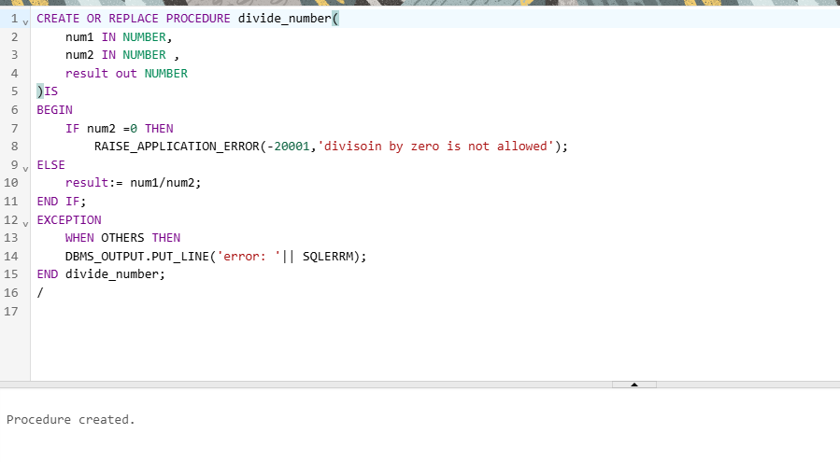
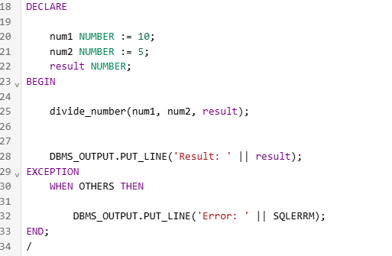

CREATE OR REPLACE PROCEDURE divide_number(
num1 IN NUMBER,
num2 IN NUMBER ,
result out NUMBER
)IS
BEGIN
IF num2 =0 THEN
RAISE_APPLICATION_ERROR(-20001,'divisoin by zero is not allowed');
ELSE
result:= num1/num2;
END IF;
EXCEPTION
WHEN OTHERS THEN
DBMS_OUTPUT.PUT_LINE('error: '|| SQLERRM);
END divide_number;
/

DECLARE

num1 NUMBER := 10;
num2 NUMBER := 5;
result NUMBER;
BEGIN

divide_number(num1, num2, result);

DBMS_OUTPUT.PUT_LINE('Result: ' || result);
EXCEPTION
WHEN OTHERS THEN

DBMS_OUTPUT.PUT_LINE('Error: ' || SQLERRM);
END;
/

Question:3
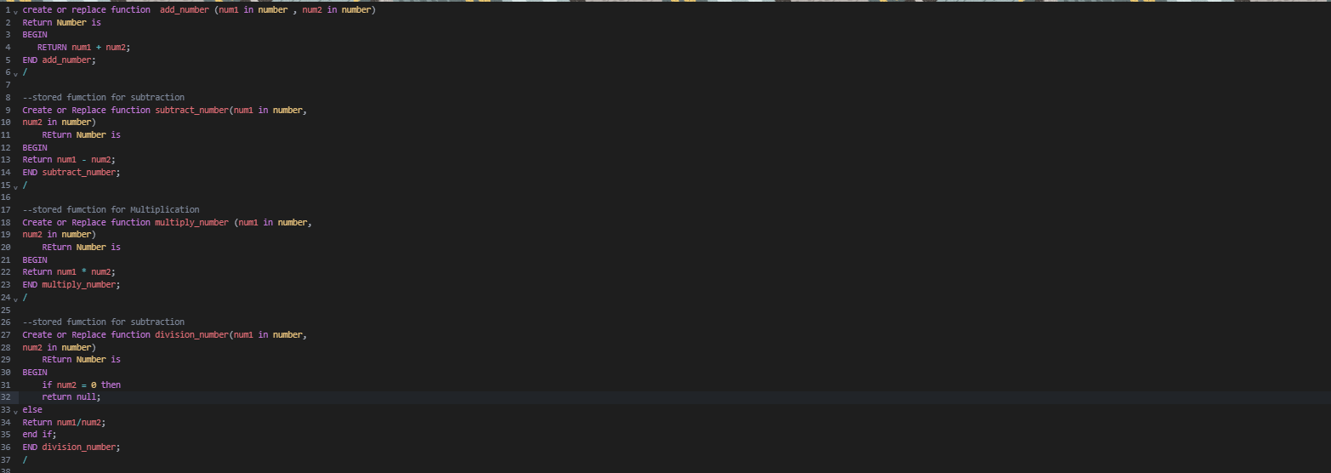
create or replace function add_number (num1 in number , num2 in number)
Return Number is
BEGIN
RETURN num1 + num2;
END add_number;
/

--stored fumction for subtraction
Create or Replace function subtract_number(num1 in number,
num2 in number)
REturn Number is
BEGIN
Return num1 - num2;
END subtract_number;
/

--stored fumction for Multiplication
Create or Replace function multiply_number (num1 in number,
num2 in number)
REturn Number is
BEGIN
Return num1 * num2;
END multiply_number;
/

--stored fumction for subtraction
Create or Replace function division_number(num1 in number,
num2 in number)
REturn Number is
BEGIN
if num2 = 0 then
return null;
else
Return num1/num2;
end if;
END division_number;
/

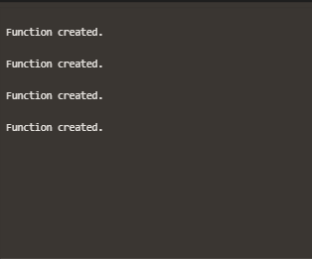

Question:4

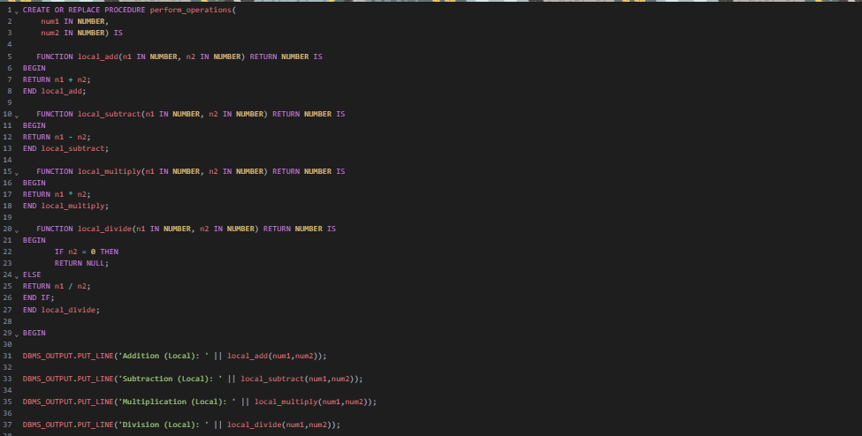

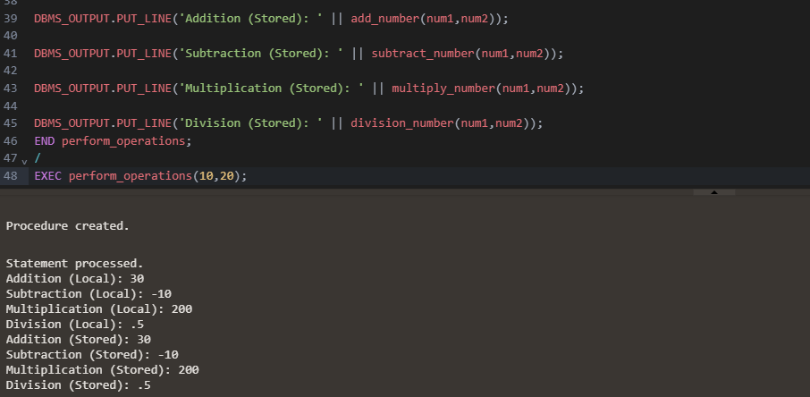
CREATE OR REPLACE PROCEDURE perform_operations(
num1 IN NUMBER,
num2 IN NUMBER) IS

FUNCTION local_add(n1 IN NUMBER, n2 IN NUMBER) RETURN NUMBER IS
BEGIN
RETURN n1 + n2;
END local_add;

FUNCTION local_subtract(n1 IN NUMBER, n2 IN NUMBER) RETURN NUMBER IS
BEGIN
RETURN n1 - n2;
END local_subtract;

FUNCTION local_multiply(n1 IN NUMBER, n2 IN NUMBER) RETURN NUMBER IS
BEGIN
RETURN n1 * n2;
END local_multiply;

FUNCTION local_divide(n1 IN NUMBER, n2 IN NUMBER) RETURN NUMBER IS
BEGIN
IF n2 = 0 THEN
RETURN NULL;
ELSE
RETURN n1 / n2;
END IF;
END local_divide;

BEGIN

DBMS_OUTPUT.PUT_LINE('Addition (Local): ' || local_add(num1,num2));

DBMS_OUTPUT.PUT_LINE('Subtraction (Local): ' || local_subtract(num1,num2));

DBMS_OUTPUT.PUT_LINE('Multiplication (Local): ' || local_multiply(num1,num2));

DBMS_OUTPUT.PUT_LINE('Division (Local): ' || local_divide(num1,num2));

DBMS_OUTPUT.PUT_LINE('Addition (Stored): ' || add_number(num1,num2));

DBMS_OUTPUT.PUT_LINE('Subtraction (Stored): ' || subtract_number(num1,num2));

DBMS_OUTPUT.PUT_LINE('Multiplication (Stored): ' || multiply_number(num1,num2));

DBMS_OUTPUT.PUT_LINE('Division (Stored): ' || division_number(num1,num2));
END perform_operations;
/
EXEC perform_operations(10,20);

